
School of Tech
Bachelor of Business Information Management Cover Sheet and Student Declaration

This sheet must be signed by the student and attached to the submitted assessment.
Course Title: | BBIM502 Introduction to Programming | Course code: | BBIM502
Student Name: | DIPSON KHATRI CHHETRI | Student ID: | 850008431
Assessment No & Type: | Assessment 1  Practical Assignment | Cohort: | BBIM7226C-Yr1
Due Date: | 14 AUGUST | Date  Submitted: | 14 AUGUST
Tutor’s Name: | GIANG
Assessment Weighting | 40%
Total Marks | 100

Student Declaration:
I declare that:
- I have read the New Zealand School of Education Ltd policies and regulations on assessments and understand what plagiarism is.
- I am aware of the penalties for cheating and plagiarism as laid down by the New Zealand School of Education Ltd.
- This is an original assessment and is entirely my own work.
- Where I have quoted or made use of the ideas of other writers, I have acknowledged the source.
- This assessment has been prepared exclusively for this course and has not been or will not be submitted as assessed work in any other course.
- It has been explained to me that this assessment may be used by NZSE Ltd, for internal and/or external moderation.
- If I am late in handing in this assessment without prior approval (see student regulations in handbook), marks will be deducted, to a maximum of 50%.

Student signature: DIPSON

Date: 14 AUGUST

Tutor only to complete
Assessment result: | Mark /100 | Grade
LO1 Requirements | ⇨ Met  ⇨ Not Met | Assessor Signature

© NZSE - BBIM502 Introduction to Programming Assessment 1 [Practical Assignment] v1.4

PART A (Programming Fundamentals)

Task 1: Variables & Data types

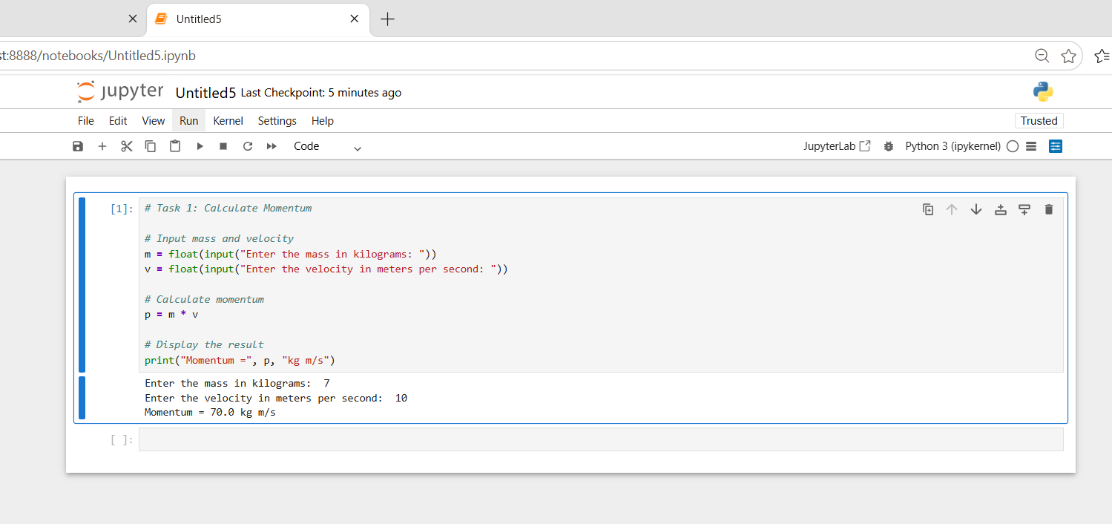

Explanation of the Program
The program to calculate the momentum the formula to do this is p=m v where m=mass and v=velocity We store a in the integer data-type of 7 kg and store a in the integer data-type of 10 m /s. We can simply store them as integers as they do not have decimal points We then multiply m by v and store in p. The print statement can then display the value of both the variables and also the result that we had calculate with the function.

Task 2: Arithmetic Operators
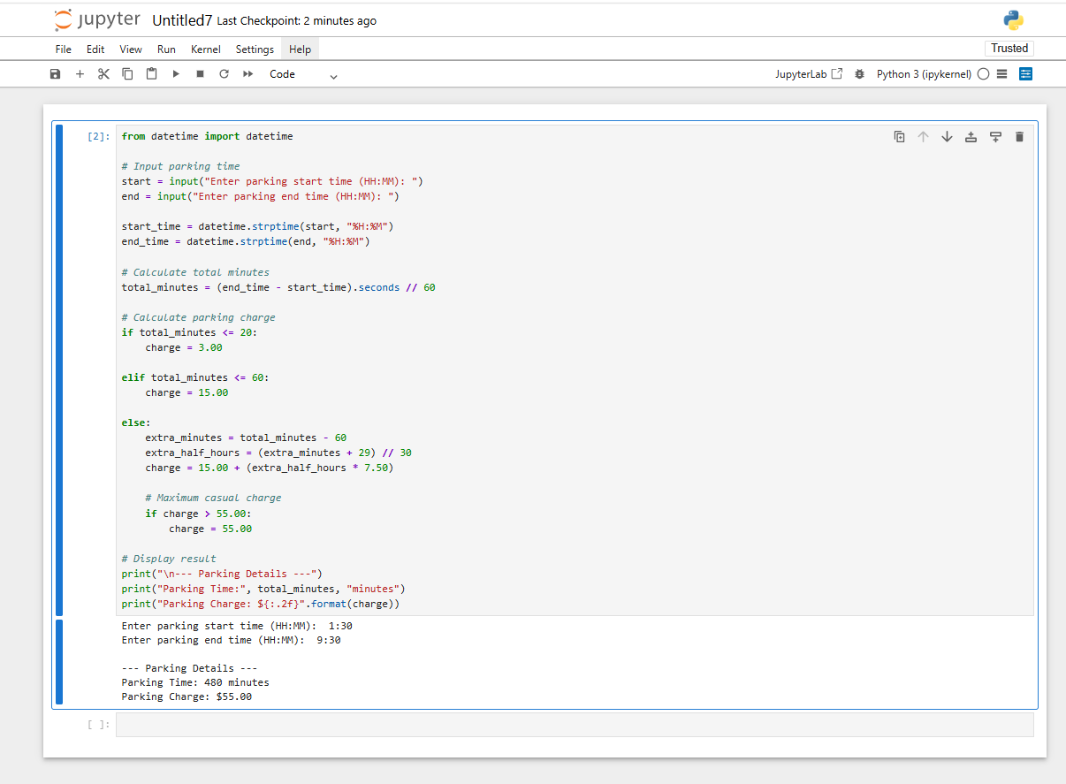
Explanation of the Program
This program computes the price to park in the parking garage according to the length of time your car has been there. It takes start time and ending time and outputs time spent parked in minutes by means of calculation. This program applies the charges to you by use of If, Elif and else statements. $3 charge if the car is parked up to 20 mins, $15 if up to 60 mins.
Additional $7.50 for every 30 minutes or every portion there of after first 60 mins with $55 maximum charge on a casual parking entry. It also helps the user to understand the use of variables, calculation operations, decision making, Input, and Out put.

Task 3: Comparison Operators

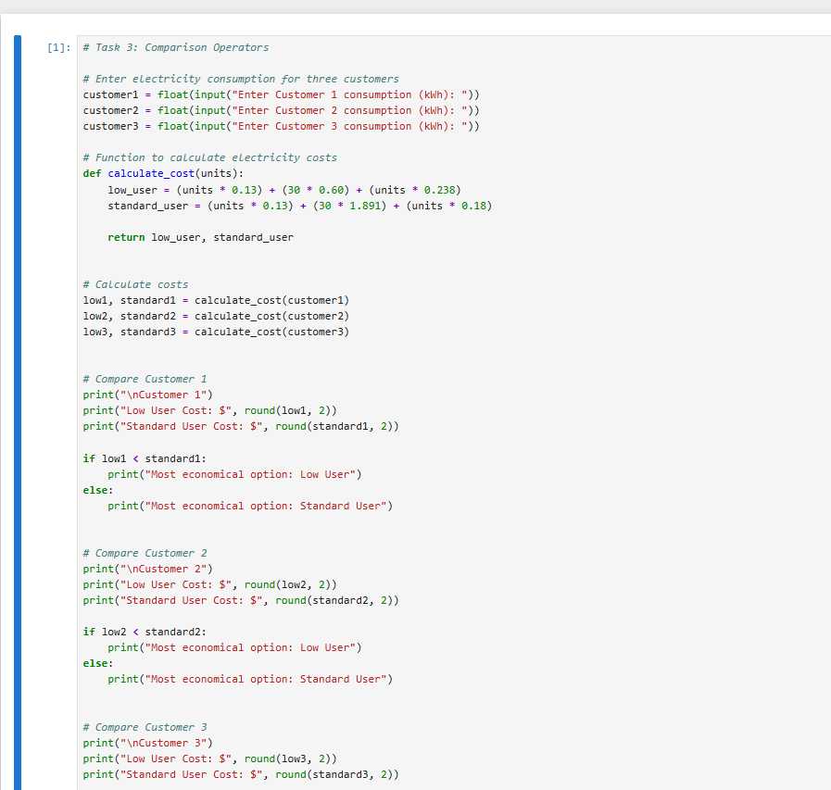
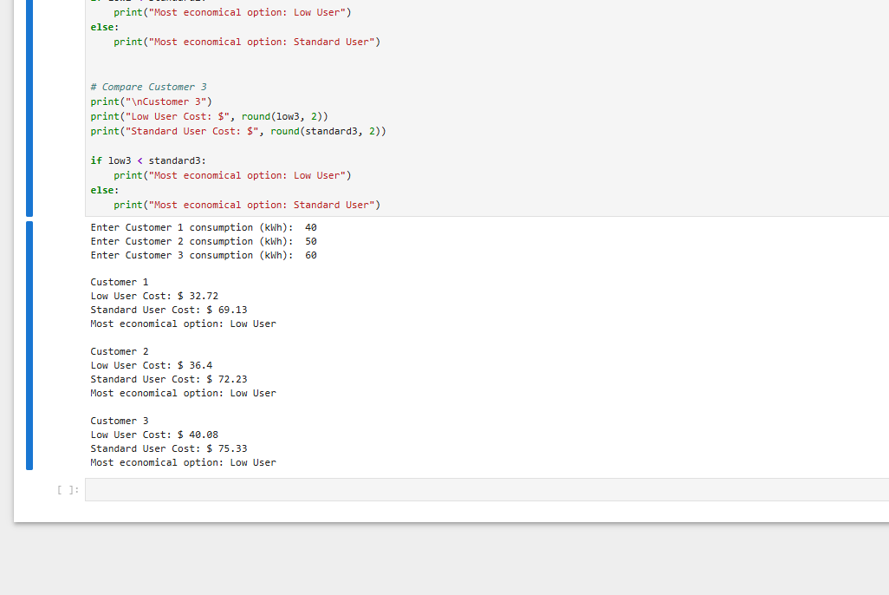

Explanation of the Program
This program demonstrates a real-time electricity rate calculation, which finds the best deals for three consumers, comparing the total cost, taking electricity authority levy, daily cost for a 30-day month, and all day economy rate into account. The basic comparison operator “<“ are applied, to establish whether the consumer may save money on one tariff with versus another. The program compares the Low User’s total cost with the Standard User’s total cost.
If the Low User’s total cost is less than the Standard User’s total cost, a Low User “tariff” suggestion is made, else suggest a Standard User. Here we illustrate functions, operands, I/O, and a use of comparison operator.

Task 4: Logical Operators
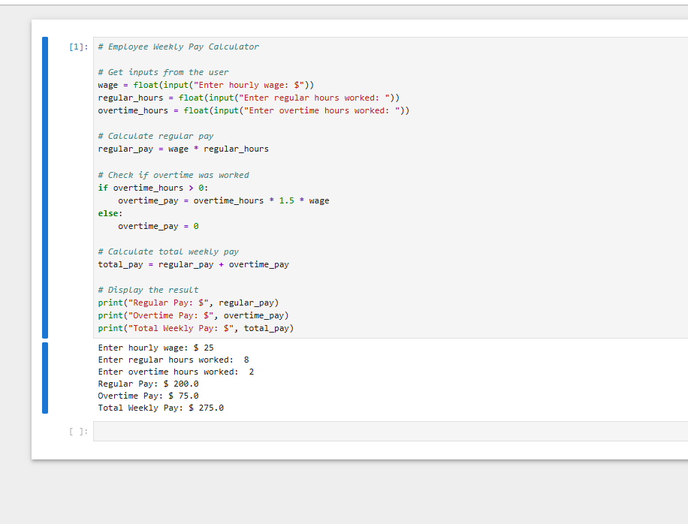

Explanation of the Program
This program will determine a worker's total weekly pay given an hourly wage and an amount of regular hours and overtime hours provided by the user. Regular pay is an employee's hourly wage multiplied by their regular hours, with no regard to whether they get paid time and half for overtime. This uses a greater than comparison operator to determine how many overtime hours the employee will use.
If the greater than 0 operation results in the true, the calculation 1.5 * (hourly wage) is utilized for overtime Pay.
It will yield 0 If no overtime hours are supplied. Sum the regular pay and overtime Pay, then the sum is displayed as this worker's total weekly pay. The following is a program in which, through the use of many of the elementary features, has a result a sum of the regular pay and overtime pay which equal total pay.

PART B (Functions and Data Structures)

Task 5: Simple Function with Parameters
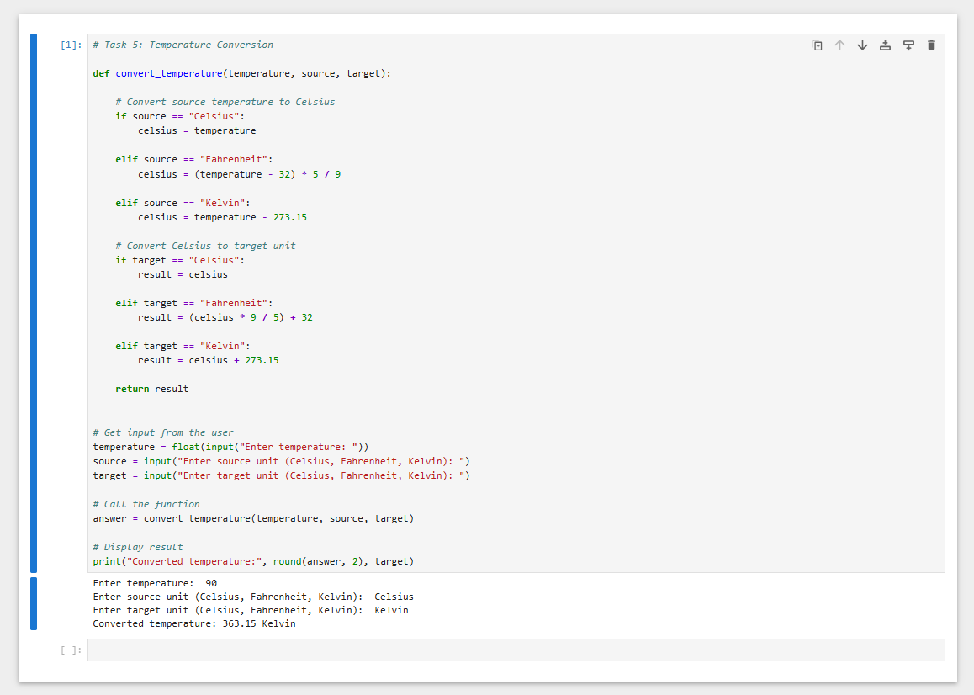

Explanation of the Program
This program converts temperature from one unit to another using a user-defined function called convert_temperature(). The function takes three parameters: temperature, source unit, and target unit. The program first converts the source temperature into Celsius. It then converts the Celsius value into the selected target unit using the appropriate temperature conversion formula. The if and elif statements are used to select the correct conversion.
The program demonstrates the use of a user-defined function, parameters, variables, conditional statements, arithmetic operators, input, and output.

Task 6: Function with Arrays

Fibonacci Sequence in Honeybees breeding
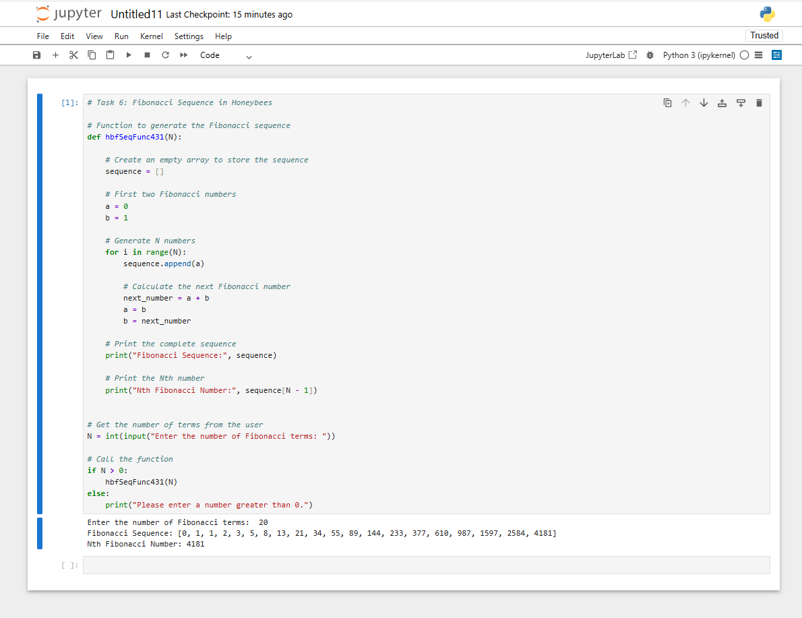

Explanation of the Program
This program demonstrates the Fibonacci sequence using the honeybee breeding example. The Fibonacci sequence is 0, 1, 1, 2, 3, 5, 8, 13 and so on. Each new number is calculated by adding the previous two numbers. A user-defined function named hbfSeqFunc431 is created with the parameter N. An array called sequence is used to store the Fibonacci numbers. A for loop generates the first N numbers and adds each number to the array using append().
The program then prints the complete Fibonacci sequence and the Nth number from the array. Comments are included in the code to make it easy to understand. This program demonstrates the use of functions, parameters, arrays, loops, variables, arithmetic operators, and conditional statements.

Task 7: Data structures: List
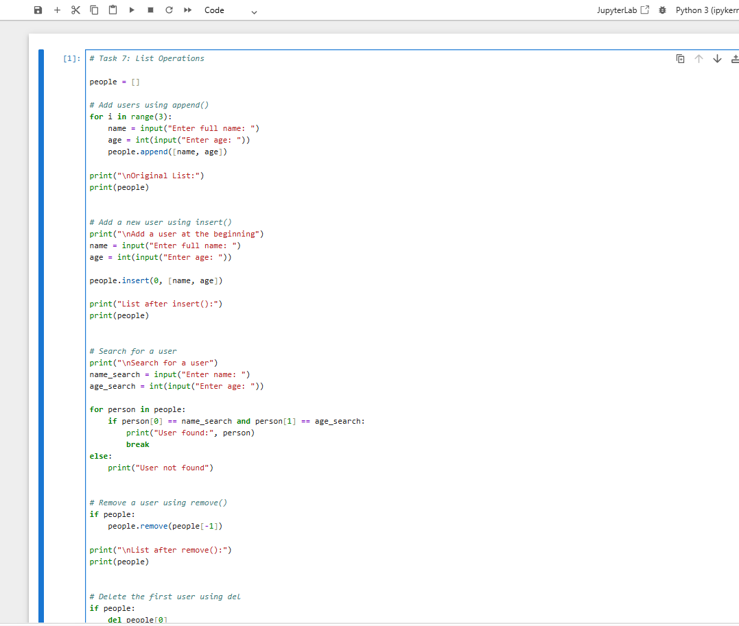

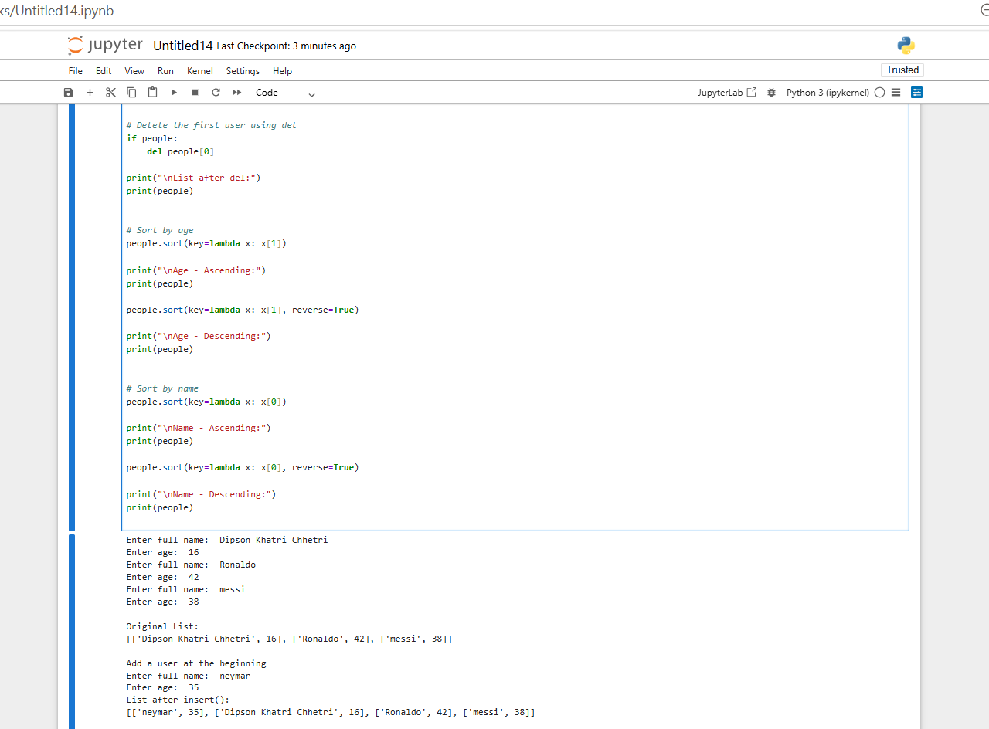

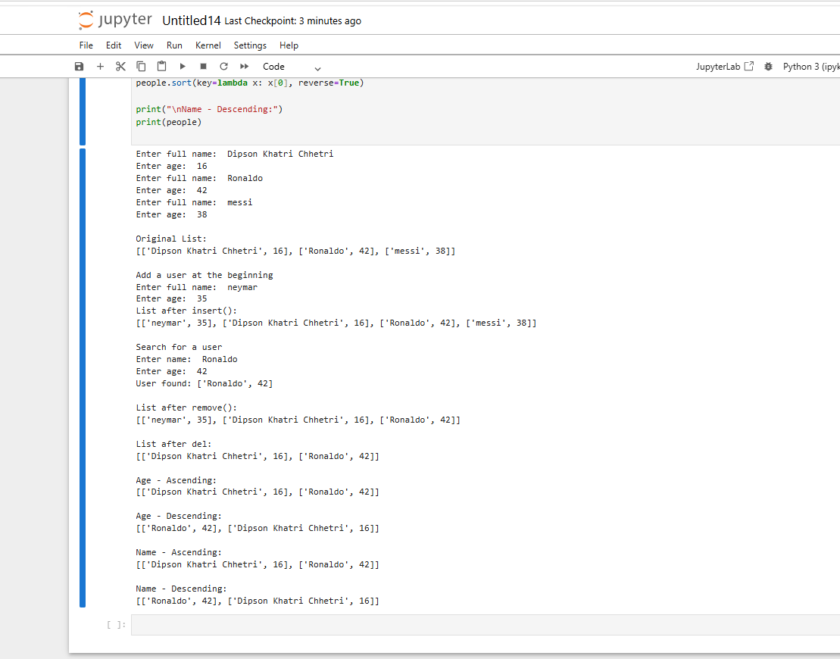

Explanation of the Program
This program stores the full name and the age of the users as a python list. Using the append()method we store the user in the list whereas the insert()method is used to insert some one at some particular place in the python list. We search for any user, using the full name and the age, by iterating the list we search for the user; The remove()method removes an element from the list whereas use del method we can remove any element from the list by index. The sort()is method used to sort the names as well as age of the list in an ascending order where reverse=True will sort it in a descending manner; the program implements storing the value ,finding ,removing deleting and storing value in a list.

Task 8: Data structures: Dictionary
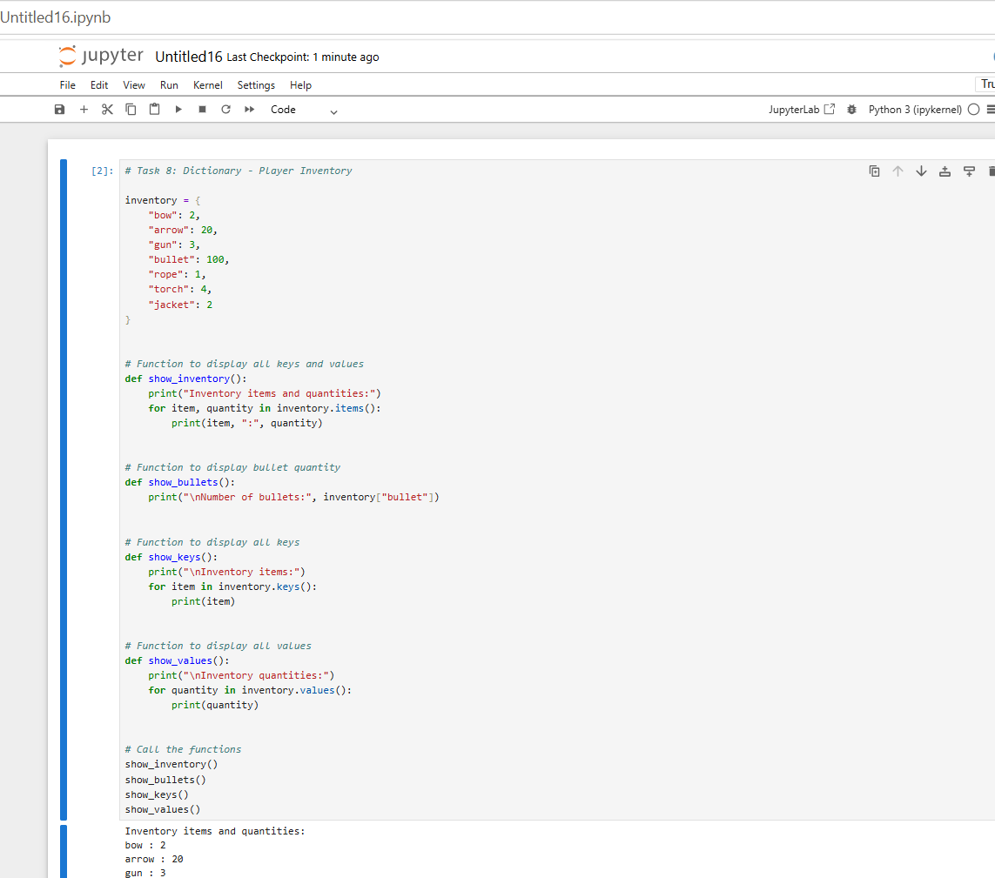

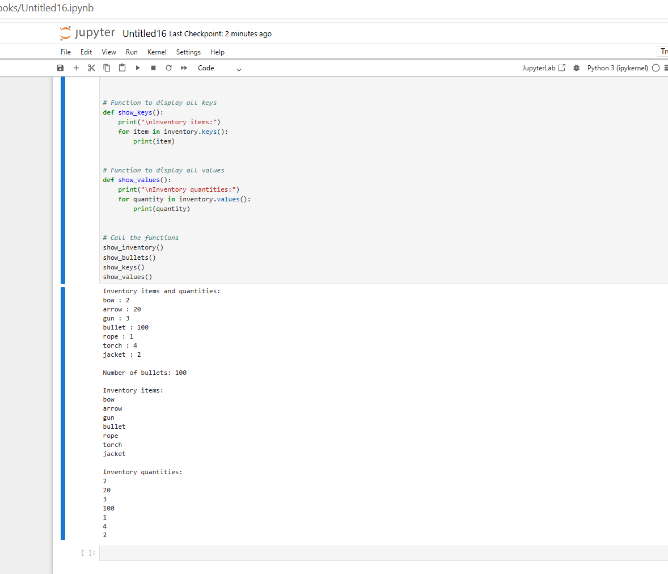

Explanation of the Program
This program uses a Python dictionary to store the player's inventory. The dictionary contains item names as keys and the quantity of each item as values. Four user-defined python functions are constructed in this program for every different objective; these functions exhibit the complete set of information stored inside the dictionary which further displays details regarding every item. The function showInventory() uses the items function to print each key and every value from the dictionary, in addition the showBullets() functions displays number of bullets for game play for which you access the values of bullet key from dictionary; and function called showKeys() prints just keys of dictionary; and the last function called showValues() which prints all values.

